Experiment No. 3
Decision Tree and Random Forest for Classification
Name : Rishabh Ramani
Class : D15B
Roll No : 48
Batch : B

Aim
Apply Decision Tree and Random Forest for classification tasks.

1. Dataset Source
- Dataset Name: ICC Cricket World Cup 2023 Match Dataset
- Source: https://www.kaggle.com/datasets/maulikpatel1930/cricket-world-cup-2023
This dataset contains detailed match-level information from the ICC Cricket World Cup 2023.

2. Dataset Description
The CWC 2023 dataset consists of structured match statistics collected for each World Cup match.

Dataset Size:
- Number of records: 48 matches
- Number of features: 44 attributes

Important Features:
- Match details: Match ID, Match Date, City, Stadium
- Team details: Team A, Team B, Toss Winner, Toss Decision
- Batting statistics: Score, Wickets, Overs, Boundaries, Run Rate
- Match outcome details: Winning Team, Margin, Man of the Match

Target Variable: Winning Team
- Multiclass categorical variable
- Represents the team that won the match

Dataset Characteristics:
- Mixed data types (categorical + numerical)
- Multiclass classification problem
- Real-world sports analytics dataset
- No time-series dependency (each match is independent)

3. Mathematical Formulation of the Algorithms

Decision Tree Classifier
A Decision Tree classifies data by recursively splitting the dataset based on feature values that maximize class separation.

Entropy:
Entropy(S) = -Σ pᵢ log₂(pᵢ)
Where: pᵢ = probability of class i, c = number of classes (teams)

Information Gain:
IG(S, A) = Entropy(S) - Σ (|Sv|/|S|) Entropy(Sv)
The feature with the highest Information Gain is selected as the split node.

Random Forest Classifier
Random Forest is an ensemble learning technique that combines multiple Decision Trees.

Bagging (Bootstrap Aggregation):
- Each tree is trained on a random subset of matches
- Sampling is done with replacement

Final Prediction: ŷ = majority vote of all trees
Random feature selection at each node improves diversity and reduces overfitting.

4. Algorithm Limitations

Decision Tree Limitations
- Overfits when many categorical features exist (teams, umpires, stadiums)
- Sensitive to noisy features like toss decision or match margin
- Greedy splitting may not produce globally optimal trees

Random Forest Limitations
- High computational cost due to multiple trees
- Less interpretable compared to a single Decision Tree
- Requires careful hyperparameter tuning
- Large memory usage

5. Methodology / Workflow
- Load the CWC 2023 dataset
- Handle missing values (if any)
- Encode categorical features (Team names, City, Stadium, Toss Winner)
- Select Winning Team as the target variable
- Split data into training and testing sets
- Train Decision Tree and Random Forest classifiers
- Evaluate performance using classification metrics
- Tune hyperparameters
- Compare results

Workflow: CWC2023 Dataset → Data Cleaning & Encoding → Train-Test Split → Model Training (DT/RF) → Prediction → Performance Evaluation

6. Performance Analysis
Evaluation Metrics Used:
- Accuracy
- Precision
- Recall
- F1-score
- Confusion Matrix

Performance Interpretation:
- Decision Tree shows moderate accuracy but high variance
- Random Forest provides higher accuracy and stable predictions
- Ensemble learning reduces overfitting caused by match-specific noise
- Random Forest performs better due to diverse decision boundaries

7. Hyperparameter Tuning

Decision Tree Tuning Parameters
- max_depth – controls tree height
- min_samples_split – prevents overfitting
- criterion – entropy or gini
Impact: Improves generalization and reduces overfitting.

Random Forest Tuning Parameters
- n_estimators – number of trees
- max_features – features per split
- max_depth – depth of individual trees
- min_samples_leaf

Impact:
- Higher accuracy
- Reduced variance
- Better performance on unseen match data

Output:
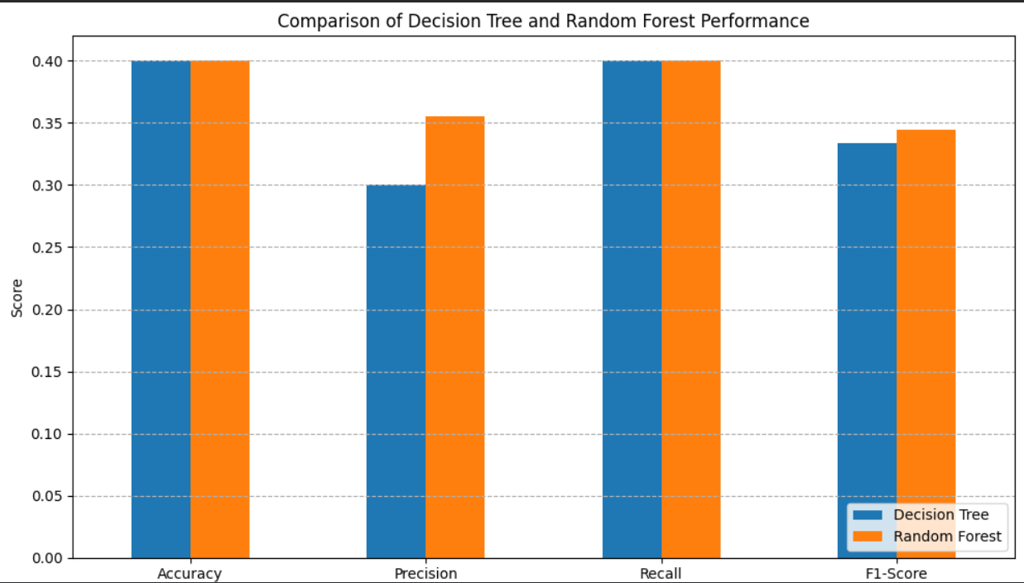
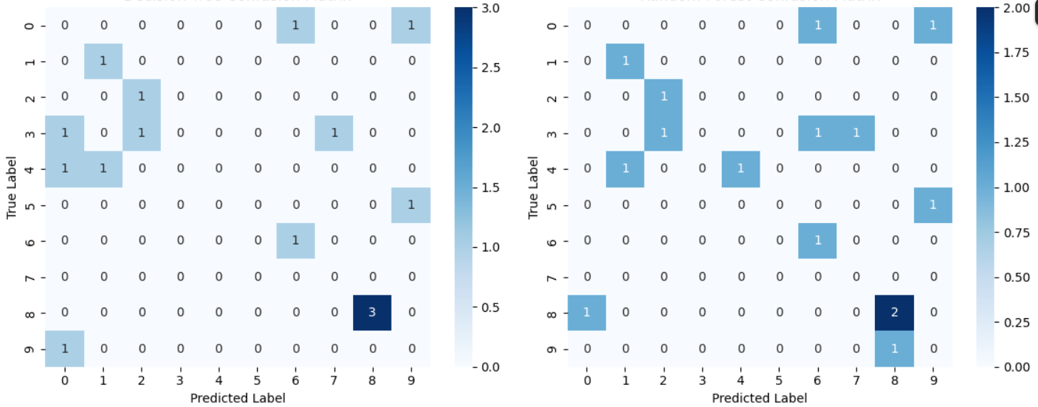

Final Conclusion
For the CWC 2023 dataset, Decision Tree provides interpretable rules based on match features but is prone to overfitting due to categorical dominance. Random Forest overcomes this limitation by aggregating multiple decision trees, resulting in improved accuracy, robustness, and reliable prediction of match-winning teams. Therefore, Random Forest is more suitable for complex sports analytics classification tasks.

